A comparison between Newcastle and Palermo
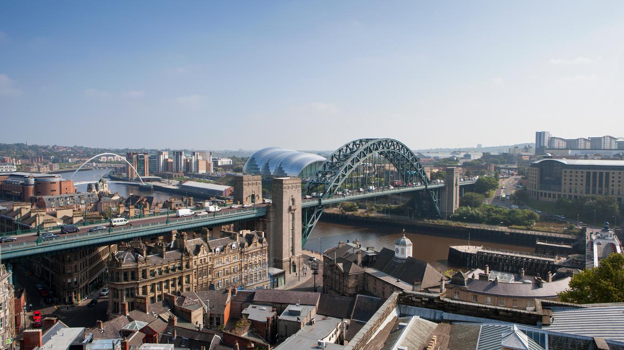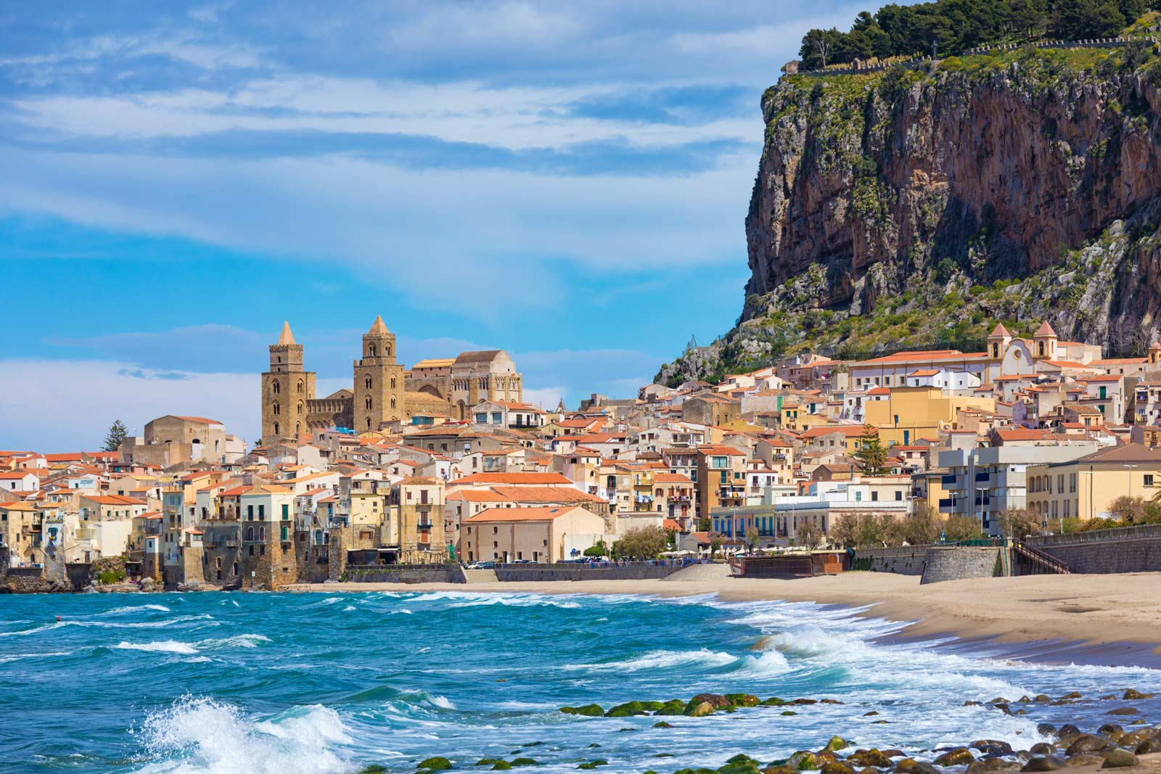
This is going to be a comparison text comparing Newcastle and Palermo. It is going to be focusing on climate, land use and buildings, transport, population and tourism and finally a conclusion.

Climate
Newcastle experiences a temperate climate whereas Palermo has Mediterranean climate. Both places experience cold and mild winters and hot summers. Palermo’s average temperatures are 31 degrees in the summer but 15 in the winter compared to 19 degrees in summer but 7 in the winter in Newcastle.

Land use and buildings
Both Newcastle and Palermo are an urban area. Newcastle has lots of ancient buildings and churches whereas Palermo only has very little. On Palermo’s side, they have the best restaurants compared to Newcastle and Palermo has a port since the country is rich of tourists coming to have a holiday there. Newcastle though has a quayside which is beautiful when the sun sets and rises. I would recommend you having a little walk round it when it is in the afternoon.

Transport
Palermo has the worst transport and it is not reliable because there are not much cars or buses. As opposed to Newcastle you can get where ever you need in no time at all. Cars is the most popular transport in Newcastle. In Palermo there is an airport there which is good but Newcastle has 7 bridges across the river tyne. In comparison, Newcastle has better transport than Palermo as it has loads of options.

Population and tourism
Newcastle has a whopping 818,000 people who are there however Palermo has 850,000 people. This is because Palermo is a bigger country and has lots of stuff there. Palermo is a very popular city because it has lots of tourist attractions with 755,000 people visiting it. This is a lot more than Newcastle as the city has 84,00 people coming to visit it. It is very cold as it is very far away from the equator. People go to Newcastle because it has a good football team and has nice beaches to visit to relax. They also go there for a romantic walk round the coast. Palermo has one of the best street food in the whole world.

As you can see, Palermo and Newcastle are different because Newcastle has very little tourism whereas Palermo is very popular. They have different climates and Newcastle is cold. On the bright side of Newcastle, it has very good transport whilst Palermo is so hard. It is hard because it is very hot and people don’t want to walk and a very hot temperature. But they also have similarities such as buses are very popular. They both have very good beaches to relax in.

