
Windy Nook Primary School
PSHE and RSE Policy
April 2026

Name of school | Windy Nook Primary School
Date of policy | April 2026
Member of staff responsible | D Smith
Review date | April 2027

Introduction
Children and young people need knowledge and skills that will enable them to make informed and ethical decisions about their wellbeing, health and relationships. High quality, evidence-based teaching of relationships, sex and health education (RSHE) can help prepare pupils for the opportunities and responsibilities of adult life, and can promote their moral, social, mental and physical development. Effective teaching will support young people to cultivate positive characteristics including resilience, self-worth, self-respect, honesty, integrity, courage, kindness, and trustworthiness. Effective teaching will support prevention of harms by helping young people understand and identify when things are not right. (Department for Education, July 2025, Relationships Education, Relationships and Sex Education (RSE) and Health Education. Statutory guidance for governing bodies, proprietors, head teachers, principals, senior leadership teams, and teachers).
Maintained schools and academies are required to provide a curriculum which is broad and balanced in accordance with Section 78 of the Education Act 2002. Under section 78 of the Education Act 2002 and the Academies Act 2010, a PSHE curriculum:

- Promotes the spiritual, moral, cultural, mental and physical development of pupils at the school and of society, and
- Prepares pupils at the school for the opportunities, responsibilities and experiences of later life.

The Relationships Education, Relationships and Sex Education and Health Education (England) Regulations 2019, made under sections 34 and 35 of the Children and Social Work Act 2017, make relationships education compulsory for all pupils receiving primary education and relationships and sex education (RSE) compulsory for all pupils receiving secondary education. They also make health education compulsory in all schools except independent schools. This is statutory guidance from the Department for Education issued under Section 80A of the Education Act 2002 and section 403 of the Education Act 1996.

Our school RSHE policy refers to both PSHE (Personal, Social, Health Education) and RSHE (Relationships, Sex and Health Education) because RSHE is included within PSHE. Our PSHE programme offers a broader range of content than RSHE alone, including citizenship education, finance education, and age-appropriate careers education.

Our PSHE policy is also informed by, Working together to safeguard children ,The Equality Act 2010, Promoting children and young people's mental health and wellbeing, The Prevent duty: safeguarding learners vulnerable to radicalisation , Behaviour in schools , Preventing and tackling bullying, Child online safety: Protecting children from online sexual exploitation and abuse , Sharing nudes and semi-nudes: advice for education settings working with children and young people, Special educational needs and disability code of practice: 0 to 25 years, EYFS statutory framework for group and school-based providers, Teaching online safety in schools, Equality and human rights guidance, Promoting fundamental British values as part of SMSC in schools

Aim of the PSHE policy
To provide pupils with the knowledge and skills they need in order to reach their potential as individuals and within society. This education also helps them explore their own and others’ attitudes and values within the local, national and global community.
In participating in PSHE learning, pupils recognise their own worth, the value of others and reflect on the multitude of the spiritual, moral, social and cultural issues they will face as young adults and beyond.
They also learn to understand and respect diversity, the rule of law, and learn ways to identify and manage risk.
In our school we choose to deliver Personal, Social, Health Education using a range of resources specifically chosen to meet the needs of or school community. These include Twinkl, Pol-Ed, Chameleon PDE, Project Evolve and Melva.

Objectives of the policy:
This policy will support the development of the skills, attitudes, values and behaviour, which enable pupils to:
- Stay safe in the on and off-line world
- Remain physically healthy and seek appropriate support to do so
- Remain emotionally healthy and seek appropriate support if they are worried about their mental health
- Form and maintain healthy and safe relationships
- Identify and manage risk
- Live and work with others
- Be active citizens
- Understand their own and others’ values, rights and responsibilities
- Consider their aspirations and develop resilience for life challenges ahead
- Live in a democratic society
- Develop personal skills such as effective communication, assertiveness, budgeting and wider life-skills

PSHE Programme Content Overview
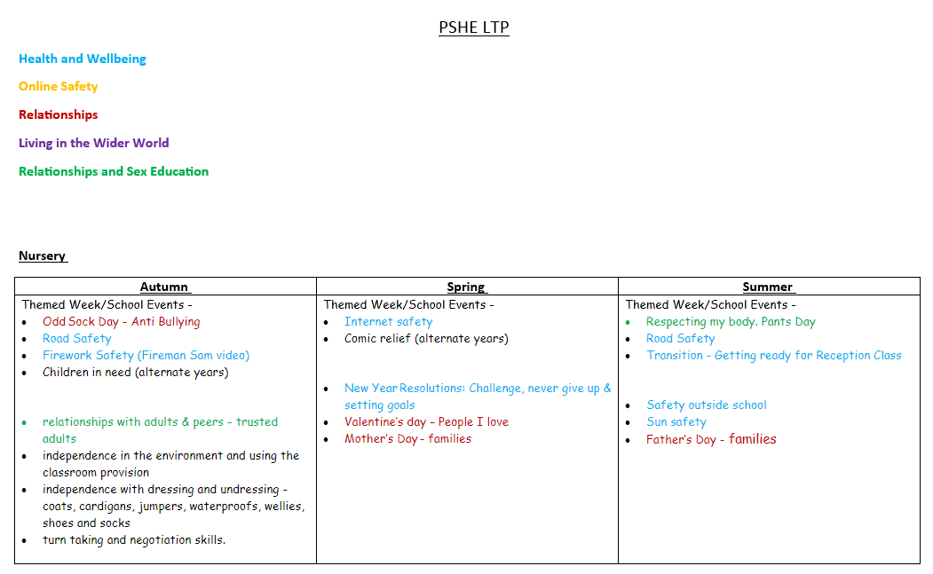
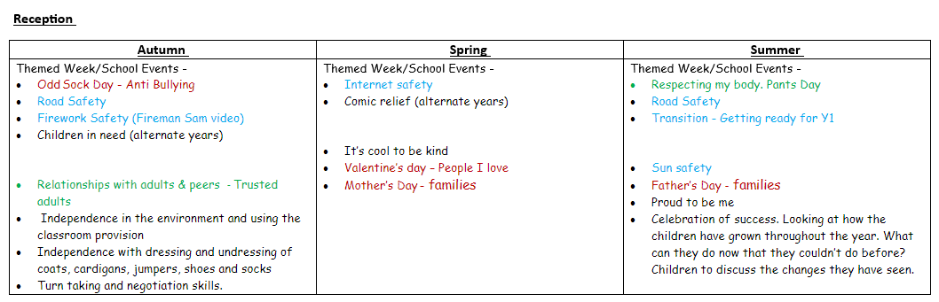
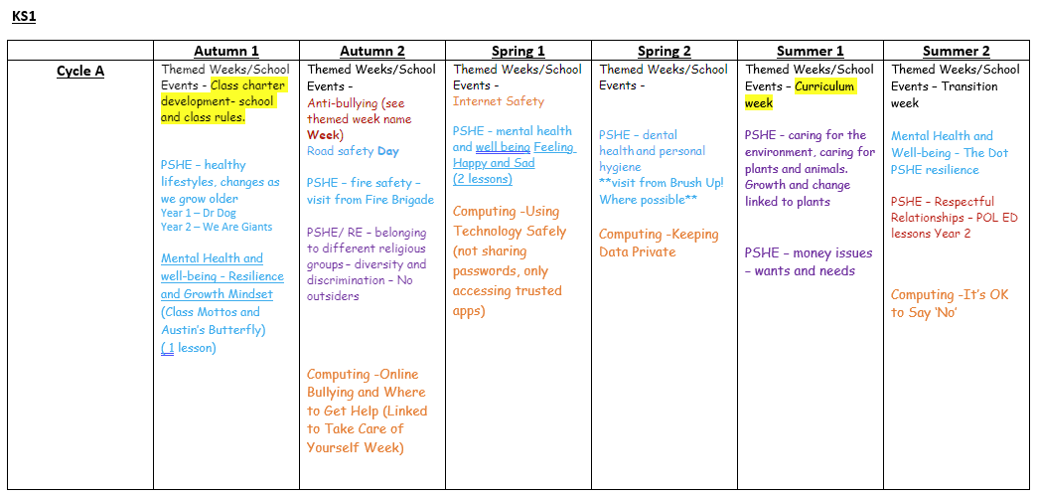
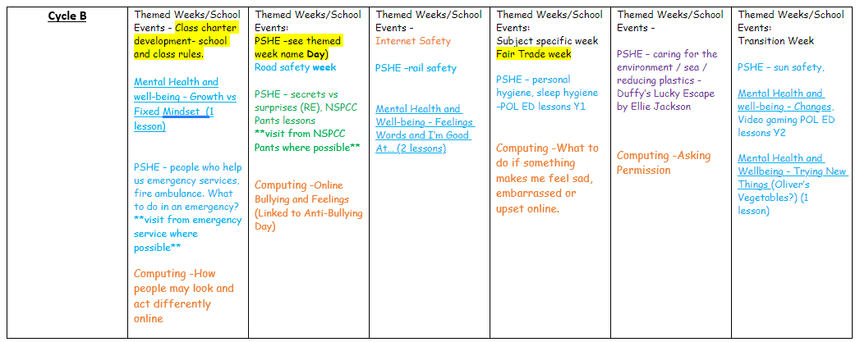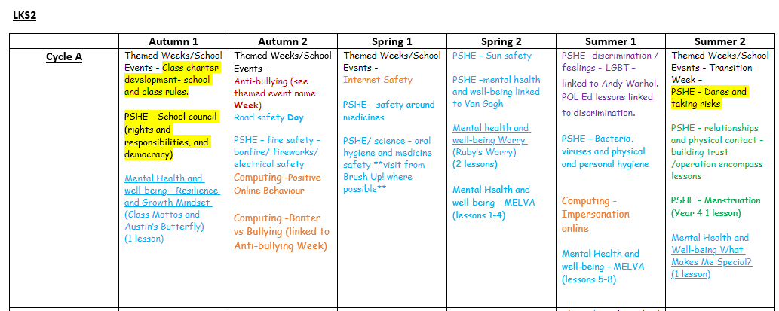
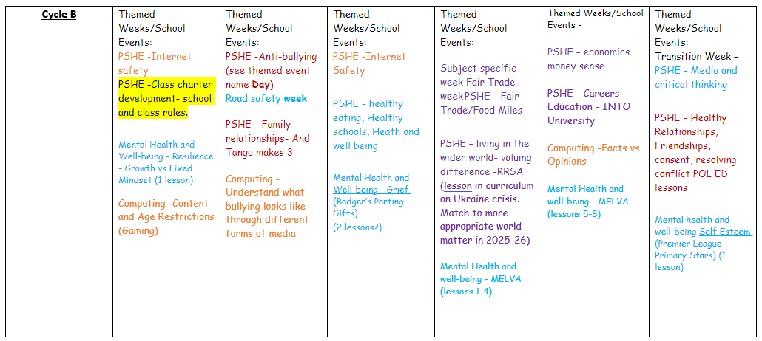

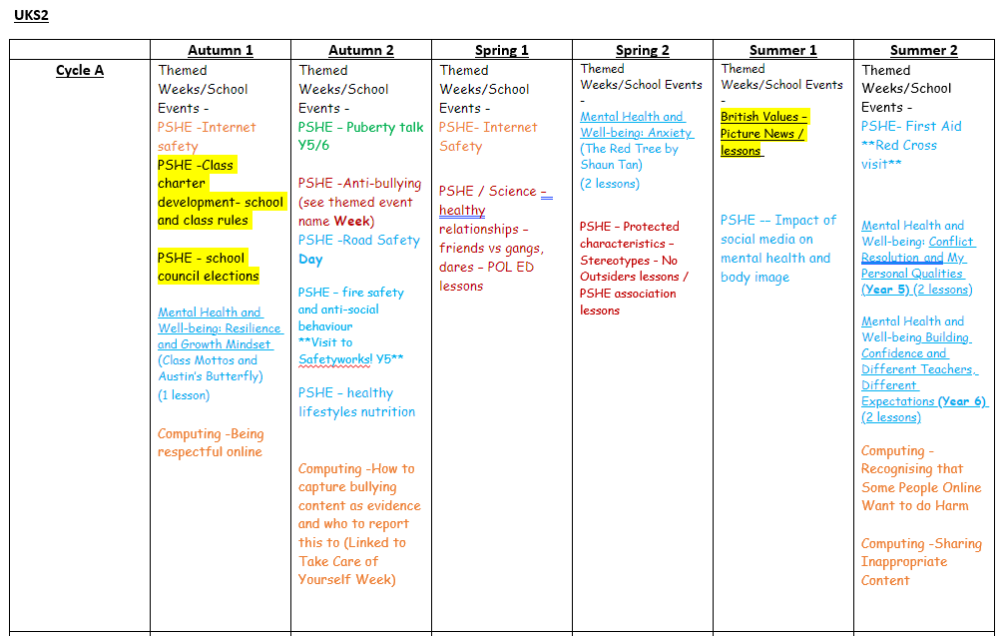
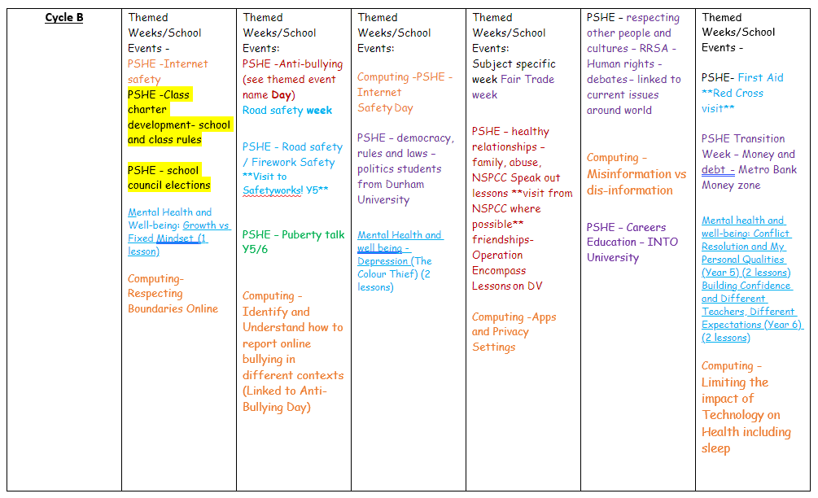

Relationship and Sex Education (Relationships, Sex and Health Education
Definition of Relationships, Sex and Health Education (RSHE)
Relationships and Health Education is compulsory for all primary schools as set out in the DfE Guidance (2025). Primary schools may provide additional age-appropriate sex education outside that covered by statutory Health Education (Developing Bodies), and this can be included within PSHE or as part of the statutory Science curriculum (life-cycles).
All schools are legally obliged to have an up-to-date policy for Relationships and Sex Education (RSE) that describes the content and organisation of RSE, and these details are included within this policy. We have also chosen to include Health Education in this policy in line with best practice. This PSHE policy is available to anyone on request and is also available on the school website. It is our school governors’ responsibility to ensure that the policy is developed and implemented effectively. Parent consultation in 2026 indicated to governors that parents would prefer for our pupils not to be taught any sex education outside that covered by statutory Health Education covered by the science curriculum. Parents therefore do not have the right to withdraw children from this area of the RSE curriculum.
We define Relationships Education as learning how to form and sustain positive relationships but will also help children identify risks and harms. Relationships education may therefore include topics related to preventing sexual abuse, for example, or avoiding sharing inappropriate material online. This can be done without describing the detail of any sexual activity involved.

Parental withdraw from sex education
Parents and carers have the right to request that their child be withdrawn from some or all of sex education outside of that taught within and as part of the Science curriculum. They cannot withdraw from any Relationships or Health Education lessons, and this includes lessons about puberty. (Section 21, DfE, 2025, Relationships Education, Relationships and Sex Education (RSE) and Health Education). Children learning correct terminology for body parts is also a statutory requirement as set out in Section 40 of the statutory guidance for Health Education (DfE, 2025). Body terminology is introduced in KS1 and reinforced in Years 4,5,6 throughout various PSHE and Science topics. This is not considered to be sex education from which parents can withdraw.
The school delivers only the statutory elements of Relationships and Sex Education (RSE), Health Education and National Curriculum Science. In line with statutory guidance, parents/carers do not have the right to withdraw their child from these areas of the curriculum.
Where parents/carers have questions or concerns about the content of the PSHE curriculum, the school will work with them to explain the nature and purpose of the curriculum and how it supports pupils' personal development, wellbeing and safeguarding. The school will provide information about the content taught and respond to any queries in a timely and supportive manner.

Transparency with parents/ carers about the PSHE curriculum and resources
Parents and carers have the right to see a representative sample of materials used within the teaching of RSHE and can do so by prior appointment with a member of staff, or at any open evening the school chooses to hold about this curriculum area. As many PSHE materials are copyrighted the school is not permitted to put teaching materials on any public facing website or social media. On request any parent/carer can request to see all materials their child will be taught as part of Relationships, Health and Sex Education.

If the school receives a written request from a parent/ carer, from within our school community, to view the curriculum materials used in RSHE then an appointment will be made for the parent to come into school and view the materials.

If RSHE materials are sent home for parents/carers to view, they will be issued with a statement, that as a condition of access, the content should not be copied or shared further except as authorised under copyright law.

The school consults parents/carers when developing this policy through our parent and carer questionnaire. The school gives serious consideration to any comments from parents/carers about the RSHE policy and teaching programme. The overall decision about the content of the school’s PSHE programme lies with the school, informed by statutory duties, so parents/carers are not able to veto curriculum content.

Links with other policies in school

PSHE has clear links with other school policies aimed at promoting pupils’ spiritual, moral, social and cultural development, including these:

- Anti-Bullying Policy
- Behaviour Policy
- Confidentiality Policy
- Drug and Alcohol Education Policy
- Equal Opportunities Policy
- Health and Safety Policy
- Healthy Eating – food in school policy
- ICT Policy and Safe Internet Use Policy
- Safeguarding/Child Protection Policy
- SEND Policy
- Visitor Policy
- Teaching and learning Policy
- Other curriculum subjects e.g., Science, RE, Computing

The role of the Headteacher and Governing body
Our Governing body ensures:

- all pupils have an entitlement to PSHE/ RSHE;
- the school is fulfilling its statutory obligations in regard to PSHE/RSHE;
- all pupils make progress in regard to PSHE/RSHE;
- PSHE/RSHE is led effectively, managed, timetabled, resourced and well-planned so the school fulfils its statutory obligations;
- the quality of PSHE/RSHE provision is subject to regular monitoring and evaluation;
- teaching is delivered in ways that are accessible to all pupils;
- clear information is provided for parents/guardians on the subject content and the right to request that their child is withdrawn from sex education outside of any statutory elements.

The headteacher and governors monitor this policy on a regular basis.

Governors require the headteacher to keep a written record, giving details of the content and delivery of PSHE that is taught in school. Governors scrutinise materials to check they are in accordance with the school’s ethos and values framework, and to meet safeguarding obligations.

Use of visitors and external agencies

The headteacher and/ or the PSHE Subject Lead will liaise with external agencies and visitors regarding the school PSHE programme and ensures that all adults who work with pupils on these issues are aware of the school policy, and that they work within this framework as part of the school’s quality assurance and safeguarding processes.
We use the following external providers as part of our PSHE programme:
Northumbria Police
Tyne and Wear Fire Service
Gateshead School Nurses
SafetyWorks!
Red Cross
MELVA
NSPCC
Show Racism the Red Card
Into University

Parents/carers are also entitled to view resources used by any visitor/ external agency that supports the school’s RSHE curriculum in advance of the lesson(s).

PSHE and Safeguarding

Inevitably the key themes regarding safeguarding pupil wellbeing are topics that are taught within PSHE. Safeguarding is a statutory duty, and we ensure there is age-appropriate content within PSHE to educate pupils about keeping themselves and others safe.

Inclusion

The Equality Act 2010 covers the way the curriculum is delivered, as schools and other education providers must ensure that issues are taught in a way that does not subject pupils to discrimination. Schools have a duty under the Equality Act to ensure that teaching is accessible to all children. Our inclusive PSHE fosters good relations between pupils and tackles all types of prejudice and discrimination.

Schools have a legal duty to promote equality (Equality Act, 2010) and to combat bullying (Education Act, 2006). “Schools should be alive to issues such as everyday sexism, misogyny, homophobia and gender stereotypes and take positive action to build a culture where these are not tolerated, and any occurrences are identified and tackled. Staff have an important role to play in modelling positive behaviours. School pastoral and behaviour policies should support all pupils.” (DfE, 2019).

Monitoring and Evaluation
Subject leaders, SLT and the governing body monitors this policy on an annual basis. In consultation with parent and carer views via questionnaire, subject leaders report their findings and recommendations to the full governing body, as necessary.

The subject leaders, SLT and governing body reviews teaching and learning and uses this to ensure the PSHE programme remains current, closely matched to students need, and that teaching and learning is effective. Monitoring and evaluation is carried out as follows: pupil voice interviews; monitoring of books, planning and the school website; lesson drop-ins; and questionnaires for parents, carers and pupils.

How PSHE is organised in school
At our school, the majority of PSHE teaching is delivered through a cross-curricular approach. This enables children to see learning in context and make meaningful links across different aspects of the PSHE curriculum. PSHE is taught by class teachers, who are responsible for the day-to-day delivery of lessons and for creating a safe, supportive learning environment in which pupils feel confident to participate and share ideas.
In addition to cross-curricular learning, PSHE is delivered through timetabled lessons across the school. During these sessions, an emphasis is placed on active learning through planned discussions, circle time, investigations, role-play activities, puppets, group work and problem-solving activities. Opportunities are also provided for pupils to apply their learning in real-life situations as they arise, for example through resolving conflicts, collaborative project work and developing positive relationships.
The PSHE subject leader is responsible for monitoring the quality of provision, supporting staff, reviewing curriculum coverage and leading the evaluation and development of the subject across the school. Monitoring activities may include lesson observations, learning walks, pupil voice activities, planning scrutinies and work sampling. Governors are kept informed of developments within the subject and the named governor with responsibility for PSHE supports the school in monitoring the effectiveness of provision.
Pupil progress in PSHE is assessed through teacher observations, pupil discussions, reflective activities and evidence of participation and engagement in lessons and wider school life. Teachers use ongoing formative assessment to identify pupils’ understanding, attitudes and skills development and use this information to complete termly assessment documents against the PSHE and RSE objectives. Achievements are celebrated through systems such as Windy Winners, RRS certificates and Head Teacher Awards, which recognise positive attitudes to learning, personal development and active citizenship.
Children are encouraged to take part in a range of practical activities to promote active citizenship and personal responsibility, including charity fundraising, planning special events, contributing to class rules, participating in School Council meetings and taking on roles of responsibility within school.
Visitors and enrichment opportunities further enhance the PSHE curriculum. Visiting speakers, such as police officers, health professionals and members of the wider community, contribute to the taught curriculum and support key safeguarding themes. Whole-school assemblies, themed weeks, health and wellbeing activities and participation in national initiatives also enrich pupils’ learning experiences. Further details of these opportunities are included in the school’s safeguarding and enrichment curriculum documentation.
The school is committed to ensuring that staff are appropriately trained and confident in delivering PSHE. Continuing Professional Development (CPD) opportunities are provided through staff meetings, external training, local authority guidance and updates from relevant agencies and services, including Gateshead Health and Wellbeing Service where applicable.

Meeting the needs of all pupils
We recognise that children in all classes have a wide range of abilities and experiences in PSHE, and we seek to provide suitable learning opportunities for all pupils by matching the challenge of activities to individual needs, including those with SEND. This is achieved by:
- setting common tasks which are open-ended and can have a variety of responses;
- setting tasks of increasing difficulty where appropriate;
- grouping children appropriately and adapting activities to support different needs;
- providing resources of differing complexity;
- using teaching assistants to support children individually and in groups.

Windy Nook Primary School follows a bespoke PSHE and RSE curriculum which is carefully adapted to meet the specific needs of our pupils and local community. The curriculum is responsive to current issues affecting children and families and is regularly reviewed to ensure learning remains relevant, meaningful and supportive. For example, following concerns identified through dental visits and local oral health data, Reception children now take part in supervised daily toothbrushing in school to promote good dental hygiene and healthy habits from an early age. In response to local issues relating to knife crime, anti-social behaviour and the unsafe use of abandoned buildings, the school works closely with the police and other external agencies to provide targeted learning opportunities and safety workshops. Pupils are also taught about the risks associated with drugs, county lines exploitation and domestic abuse through age-appropriate lessons, assemblies, safeguarding activities and visiting professionals. This responsive approach ensures that pupils are equipped with the knowledge, understanding and skills needed to stay safe, healthy and prepared for life in their community.

Disclosures in PSHE/Managing sensitive discussions
Staff are aware that sometimes disclosures may be made during PSHE lessons; in which case, safeguarding procedures are followed as appropriate. Sometimes it is clear that certain pupils may need time to talk one-to-one after the lesson closes or needs to be signposted to further sources of advice or support. If disclosures occur, the school’s confidentiality policy is followed.
As a general rule a pupil’s confidentiality is maintained by the teacher or member of staff concerned. If this person believes that the child is at risk or in danger, they will talk to the Designated Safeguarding Lead (DSL) who takes action as laid down in the school’s safeguarding policy. All staff members are familiar with the policy and know the identity of the DSL. The pupil concerned will be informed that confidentiality is being breached and reasons why. The pupil will be supported by staff throughout the process. Visitors to the school will be advised of this process should a disclosure occur as part of their session.
The PSHE Learning Environment
Establishing a safe, open and positive learning environment based on trusting relationships between all members of the class, adults and students alike, is vital in PSHE. To enable this, we use PSHE ‘ground rules’ at the beginning of lessons which are reinforced throughout. Our pupils are also encouraged to ask questions, and share worries with members of staff in the aim to promote a welcoming and ‘open’ learning culture. This can be through discussion with a trusted member of staff or through the use of the Worry Boxes in each class.
Teaching Sensitive and Controversial Issues
Sensitive and controversial issues are certain to arise in PSHE. Teachers are prepared to handle personal issues and deal sensitively with, and to follow up appropriately, disclosures made in a group or by individual children. Issues that we address in PSHE are likely to be sensitive and controversial sometimes because they have a political, social or personal impact, or deal with different values and beliefs.
Teachers will take all reasonable, practical steps to ensure that, where political or controversial issues are brought to pupils’ attention, they are offered a balanced presentation of opposing views. Teachers will adopt strategies that seek to avoid bias on their part and will teach pupils how to recognise bias and evaluate evidence. Teachers will seek to establish a classroom climate in which all pupils are free from any fear of expressing reasonable points of view that contradict those held either by their class teachers, peers or families.
Children will be introduced to protective and preventative content in a way that does not cause unreasonable alarm and does not appear to normalise risky behaviours or activities. There may also be cases when we may need to deviate from our published PSHE policy to safeguard children, for example, if pupils have seen distressing or pornographic content online. This teaching will remain age-appropriate and respectful of all children, including those who may have no familiarity with the topics under discussion. The school will inform parents of any deviation from the published PSHE policy in advance and share any relevant materials with them on request.

Answering Difficult Questions and Managing Sensitive Issues

Both formal and informal PSHE arising from pupils’ questions are answered according to the age and maturity of the pupil(s) concerned. Questions do not have to be answered directly and can be addressed individually later. The school believes that individual teachers must use their skill and discretion in this area and refer to the PSHE Subject Lead or Designated Safeguarding Lead if they are concerned or need support.
Where possible, teaching strategies use ‘distancing’ so that pupils discuss issues ‘theoretically’ e.g., through a case study or a scenario, rather than drawing on personal experiences.
If a child asks a question related to sex education, that is not covered in school, or related to content the child has been withdrawn from, the teacher concerned may provide an answer according to the age and maturity of the child if it is appropriate to do so. If it is not appropriate to provide an answer, the teacher will refer the question to be answered at home.

Consultation with the wider community

This PSHE policy has been written in consultation with parents and carers through questionnaires and feedback opportunities to ensure that it reflects the needs and values of our school community. Guidance and advice have also been sought from the Gateshead Council and the Gateshead SSP Health and Wellbeing Team to support the development of a high-quality and effective PSHE and RSE curriculum.

Policy Review
This policy is reviewed annually.
 | Signed Headteacher | Signed Chair of Governors
Date of review:
April 2026

Date of next review:
April 2027

